library(MASS)
?crabs

data(crabs)
str(crabs)
data.frame': 200 obs. of 8 variables:
$ sp : Factor w/ 2 levels "B","O": 1 1 1 1 1 1 1 1 1 1 ...
$ sex : Factor w/ 2 levels "F","M": 2 2 2 2 2 2 2 2 2 2 ...
$ index: int 1 2 3 4 5 6 7 8 9 10 ...
$ FL : num 8.1 8.8 9.2 9.6 9.8 10.8 11.1 11.6 11.8 11.8 ...
$ RW : num 6.7 7.7 7.8 7.9 8 9 9.9 9.1 9.6 10.5 ...
$ CL : num 16.1 18.1 19 20.1 20.3 23 23.8 24.5 24.2 25.2 ...
$ CW : num 19 20.8 22.4 23.1 23 26.5 27.1 28.4 27.8 29.3 ...
$ BD : num 7 7.4 7.7 8.2 8.2 9.8 9.8 10.4 9.7 10.3 ...

crabs_tab<- table(crabs$sp,crabs$sex)
crabs_tab

Result:
F M
B 50 50
O 50 50

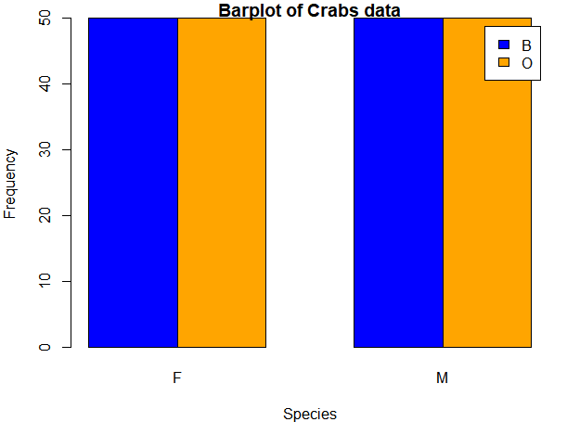
- The data is balanced. This is because there are equal blue crabs than orange crabs in both males than females.

Question 2
Boxplot of the body depth (BD) for the four groups by species and sex
?boxplot
boxplot(crabs$BD ~ crabs$sp+sex, data = crabs,
main = "Boxplot of BD by Species and Sex",
xlab = "Species",
ylab = "Body Depth",
col = c("blue", "orange"))

b) outliers <- boxplot(crabs$BD~sp+sex, data = crabs, plot = FALSE)$out

Result: > outliers
numeric(0)

Question 3

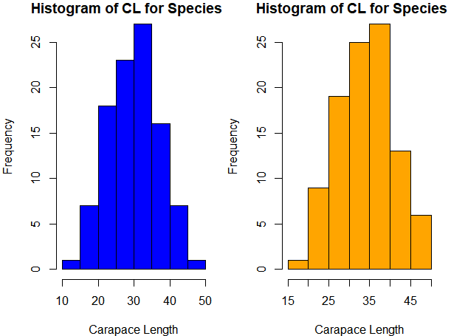

b) The histograms show that the distribution of carapace length (CL) for both species B and O is approximately normal, with species B having a slightly wider range of CL values compared to species O.
The histogram for species B is slightly right-skewed. This means that it has a longer tail on the right side. The histogram for species O on the other hand appears to be symmetric. Both histograms show a single peak, indicating that the data is unimodal.

Question 4
morph_mean <- aggregate(cbind(FL, RW, CL, CW, BD) ~ sp + sex,
data = crabs, FUN = mean)
morph_mean

Result:
sp sex FL RW CL CW BD
1 B F 13.270 12.138 28.102 32.624 11.816
2 O F 17.594 14.836 34.618 39.036 15.632
3 B M 14.842 11.718 32.014 36.810 13.350
4 O M 16.626 12.262 33.688 37.188 15.324

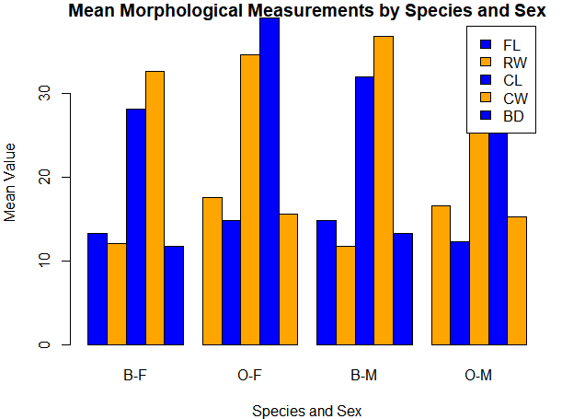

c)
species_diff <- apply(morph_mean[,-c(1,2)], 2, function(x) max(x) - min(x))
species_diff
FL RW CL CW BD
4.324 3.118 6.516 6.412 3.816

sex_var <- apply(morph_mean[,-c(1,2)], 2, function(x) abs(x[1] - x[2]))
sex_var
FL RW CL CW BD
4.324 2.698 6.516 6.412 3.816

Question 5

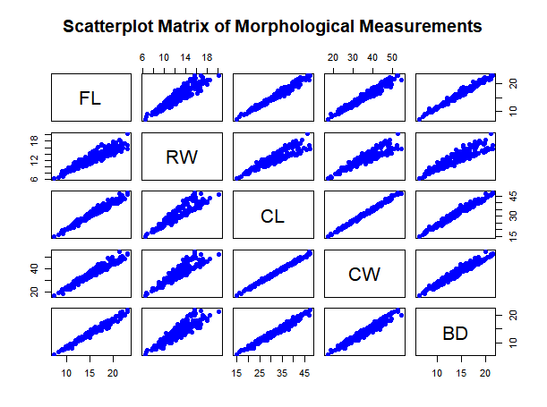
- All variable pairs in this matrix exhibit a positive linear relationship. This means that as the value of one morphological measurement increases, the value of the other measurement tends to increase as well.
Relationships involving RW and FL and RW and BD appear slightly more dispersed compared to the others. While the relationship is still strongly positive, there is more individual variation in these pairings.

Question 6
This report provides a statistical analysis of the crabs dataset from the MASS library in R. The dataset records five morphological measurements of 200 Leptograpsus variegatus (rock crabs) collected at Fremantle, Western Australia. The primary aim of this analysis is to explore the data structure, assess group balance, and evaluate the distributions and relationships of various physical dimensions; Frontal Lobe (FL), Rear Width (RW), Carapace Length (CL), Carapace Width (CW), and Body Depth (BD) across two species (Blue and Orange) and both sexes.

Analysis
1. Data Structure and Group Composition
The dataset consists of 200 observations and 8 variables. Initial inspection reveals that the five morphological measurements (FL, RW, CL, CW, and BD) are stored as numerical data. The grouping variables, Species (sp) and Sex (sex), are categorical factors with two levels each.

A frequency analysis shows that the dataset is perfectly balanced across species and sex combinations, with 50 observations for each of the four groups: Blue Female, Blue Male, Orange Female, and Orange Male.
2. Distribution of Body Depth (BD)
To investigate the typical body depth and its variation, boxplots were constructed for the four groups.
- Central Tendency and Spread: The median body depth varies across groups, with Orange crabs generally exhibiting higher values than Blue crabs.
- Outliers: A formal check for outliers using the Interquartile Range (IQR) method yielded no outliers in the BD variable for any of the four groups.
3. Shape Analysis of Carapace Length (CL)
The distribution of Carapace Length (CL) was examined using histograms to assess symmetry and modality.
- Modality: Both species (Blue and Orange) show a unimodal distribution, characterized by a single clear peak.
- Symmetry: Species O exhibits an approximately symmetric distribution. In contrast, Species B is slightly right-skewed, meaning it has a longer tail extending toward higher CL values.
- Range: Species B possesses a slightly wider range of carapace lengths compared to Species O.
4. Mean Morphological Comparisons
Aggregated mean values reveal significant differences in size based on both species and sex. Orange females (O-F) consistently show the largest mean dimensions across all five morphological traits, while Blue females (B-F) are generally the smallest.
The greatest difference between species means was observed in Carapace Length (6.516 units) and Carapace Width (6.412 units), while the smallest inter-species difference occurred in Rear Width (3.118 units).
5. Relationships Between Morphological Variables
A scatterplot matrix was used to visualize the nature and strength of the relationships among the five measurements.
- Nature: Every variable pair exhibits a strong, positive linear relationship, indicating that as one physical dimension increases, the others increase proportionally.
- Variability: While the correlations are generally very tight, relationships involving Rear Width (RW) paired with Frontal Lobe (FL) or Body Depth (BD) show slightly more individual variation than other pairings.

Conclusion
The morphological analysis of the Leptograpsus variegatus dataset confirms that these crabs maintain highly proportional growth across all measured dimensions, as evidenced by the strong positive linear correlations. While the dataset is balanced, distinct size differences exist between species and sexes, with the Orange species typically being larger.

